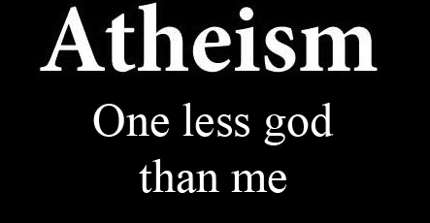
Cure the Atheism of My Heart

Lord of my heart,
I am appalled at my secret godlessness.
I am truly a functional atheist:
thinking little of you;
caring little to please you;
living a life apart from you;
building my house on other foundations.

When I want MY way, I want not YOU.
When these clouds of atheism and unbelief come to me,
I see your purpose of love
in withdrawing the Spirit that I might prize him more -
that my wound of godlessness might be cured.

Help me to humble myself.
Help me to see independence from you as a conceit of men's minds.
Remind me that in you I live and move and have my being.
Convince me that your will alone must be done,
as much in denying as in giving spiritual enjoyments,
then possess me,
for you only are good and goodness.

I am thankful that you do not play in convincing me of sin.
Satan did not play in tempting me to it.
Burn upon my heart that sin is no game, no toy, no bauble,
and that the heinousness of sin lies not so much
in the nature of the sin committed,
as in the greatness of the Person sinned against.

When I am afraid of sins to come, comfort me
by showing me that in Christ I am brought near, corrected, and satisfied;
that what holiness I now experience in Christ in part,
shortly I will have perfectly in heaven.

- The Valley of Vision, p. 79 with additions & changes.

